HOMEWORK-3

Screenshots:-

1.welcome

2.CONTACT INFORMATION

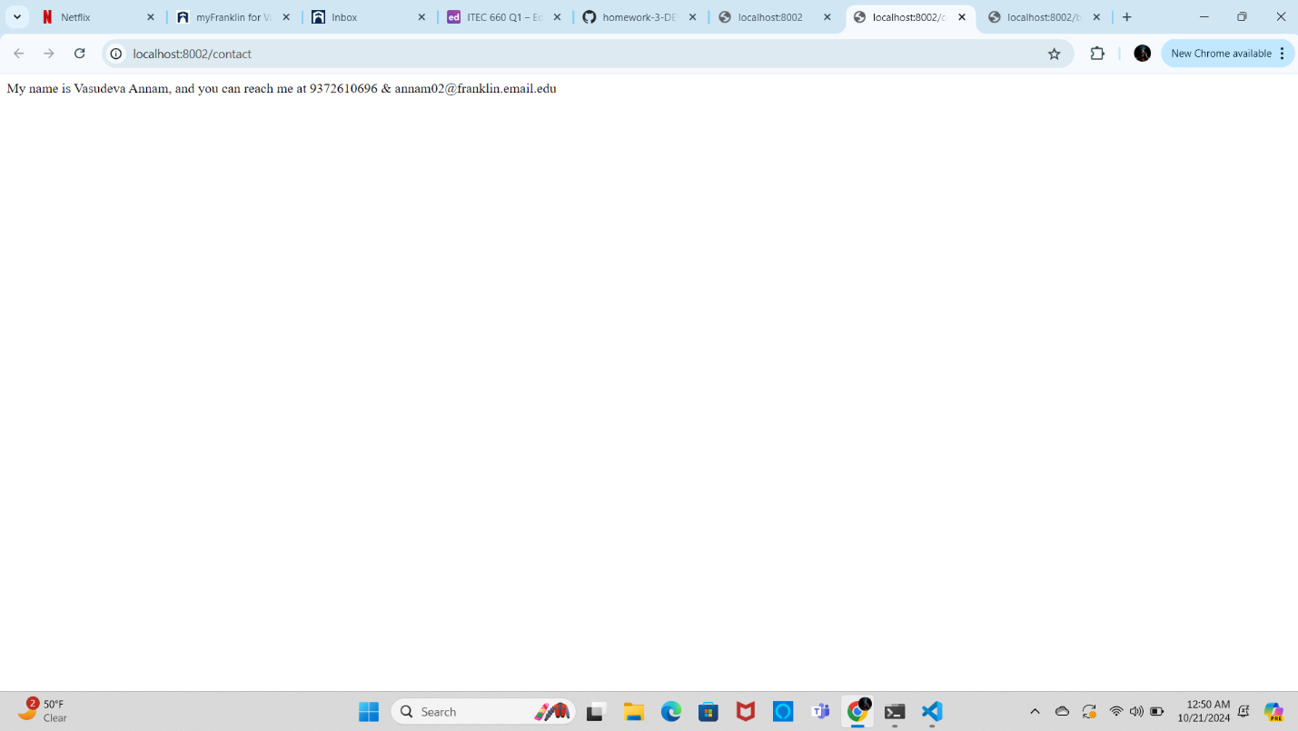

3. Bio Page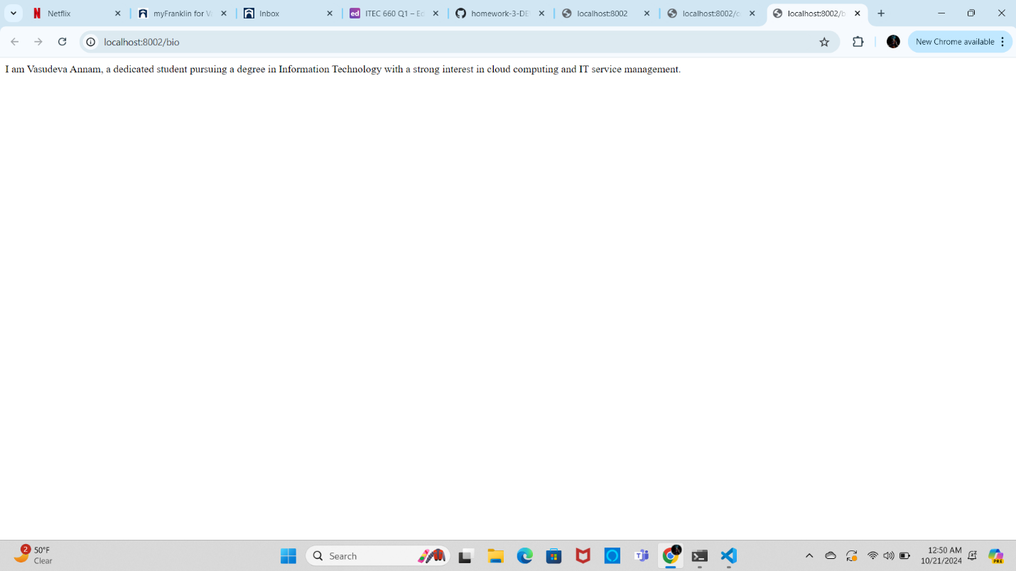

CODE PATH (visual studio code)- [C:\Users\vasud\OneDrive\Documents\GitHub\lab-1-DEV-2120\webapp\webapp.js](file:///C:\Users\vasud\OneDrive\Documents\GitHub\lab-1-DEV-2120\webapp\webapp.js)